In The Name Of God

(Problem set - 8 )

(recursion)

توجه : سوالاتی که جلوی آنها Bonus Q نوشته شده به استفاده از آرایه دو بعدی نیاز دارند . حل کردن آنها **اصلا** ضرورتی ندارد و صرفا برای تمرین شخصی میتوانید از آنها استفاده کنید .

1 - Try to code each one of these problems , which are quite famous.

( search about each one if you have no idea what it is .)**( Bonus Q)**

A - 8 queen

B - n queen

C - convex hall

D - knapsack problem

2 - assume that we are given a 9*9 sudoku table with some of the blocks empty and some of the blocks given numbers . write a function named “solve” to solve the sudoku table and prints it .**( Bonus Q)**

EX : 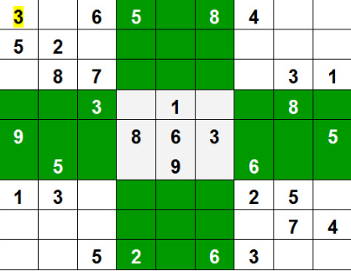

>> program input :

int[][] board = new int[][]

{

{3, 0, 6, 5, 0, 8, 4, 0, 0},

{5, 2, 0, 0, 0, 0, 0, 0, 0},

{0, 8, 7, 0, 0, 0, 0, 3, 1},

{0, 0, 3, 0, 1, 0, 0, 8, 0},

{9, 0, 0, 8, 6, 3, 0, 0, 5},

{0, 5, 0, 0, 9, 0, 6, 0, 0},

{1, 3, 0, 0, 0, 0, 2, 5, 0},

{0, 0, 0, 0, 0, 0, 0, 7, 4},

{0, 0, 5, 2, 0, 6, 3, 0, 0}

};

>>output :

3 1 6 5 7 8 4 9 2  
 5 2 9 1 3 4 7 6 8  
 4 8 7 6 2 9 5 3 1  
 2 6 3 4 1 5 9 8 7  
 9 7 4 8 6 3 1 2 5  
 8 5 1 7 9 2 6 4 3  
 1 3 8 9 4 7 2 5 6  
 6 9 2 3 5 1 8 7 4  
 7 4 5 2 8 6 3 1 9

3 - Write a piece of code to generate and print all the permutations of a given string s. the elements of the string can be distinct and the same.

Ex 1 :

input :

abc

output :

abc

acb

bac

bca

cab

cba

Ex2 :

Input :

abb

Output :

abb

bab

bba

4 - برنامه ای بنویسید که از کاربر عددی را به عنوان ورودی دریافت کرده و در متغیری به نام n بریزد و مثلث خیام پاسکال را تا مرحله n ام بکشد.

**( Bonus Q)**

5 - Write a recursive program to count the ways to express a function as sum of power Given two integers x and n, we need to find number of ways to express x as sum of n-th powers of **unique** natural numbers.

Example:

Input: x = 100

n = 2

Output: 3

Explanation: There are three ways to

express 100 as sum of natural numbers

raised to power 2.

100 = 10^2 = 8^2+6^2 = 1^2+3^2+4^2+5^2+7^2

Input: x = 100

n = 3

Output: 1

Explanation: The only combination is,

1^3 + 2^3 + 3^3 + 4^3

6 - Write a function that gets a int number from user and print if it’s palindrome or not. If not print the closet palindrome number to the given number.(use getchar and putchar functions only)

7 - Write a program that generates moore mealy state machine.

( Non- recursively )

8 - Try to solve the hanoi tower problem recursively .

( if you don’t know what hanoi is , google it )